Terraform Final Task
Terraform AWS Infrastructure Deployment
Objective: Create a VPC, Internet Gateway, custom Route Table, Subnet, Security Group, Network Interface, Elastic IP, and Ubuntu EC2 server, then install and verify Apache2.

Requirements
1. Create VPC
2. Create Internet Gateway
3. Create Custom Route Table
4. Create Subnet
5. Associate the Subnet with the Route Table
6. Create a Security Group allowing ports 22, 80, and 443
7. Create a Network Interface with a private IP in the subnet
8. Assign an Elastic IP to the Network Interface
9. Create an Ubuntu server and install/enable Apache2

Step 1 — Create Terraform Folder
Create a project folder for the Terraform configuration and open it in VS Code.
mkdir terraform-final-task
cd terraform-final-task
code .
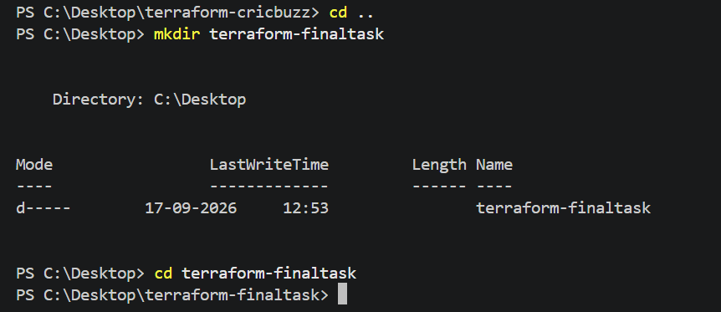
Screenshot 1 — Original task evidence

Step 2 — Project File Structure
Create separate Terraform files for the AWS components.
terraform-final-task/
├── provider.tf
├── variables.tf
├── vpc.tf
├── subnet.tf
├── route.tf
├── security-group.tf
├── network-interface.tf
├── elastic-ip.tf
├── ec2.tf
└── outputs.tf
Screenshot 1 — Original task evidence

Step 3 — Configure AWS Provider
Configure the AWS provider and keep the AWS region in a variable.
terraform {
required_providers {
aws = {
source = "hashicorp/aws"
version = "~> 6.0"
}
}
}
provider "aws" {
region = var.aws_region
}
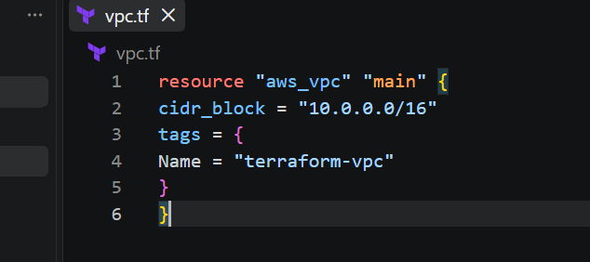
Screenshot 2 — Original task evidence
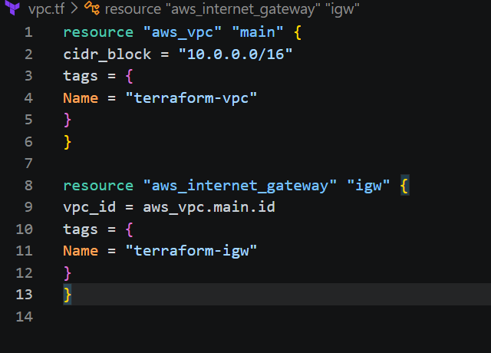
Screenshot 3 — Original task evidence

Step 4 — Define Variables
Define the region, network CIDRs, availability zone, instance type, key pair, private IP, and Ubuntu AMI ID.
variable "aws_region" {
default = "us-east-1"
}
variable "vpc_cidr" {
default = "10.0.0.0/16"
}
variable "subnet_cidr" {
default = "10.0.1.0/24"
}
variable "availability_zone" {
default = "us-east-1a"
}
variable "instance_type" {
default = "t2.micro"
}
variable "key_name" {
default = "Krishna6"
}
variable "private_ip" {
default = "10.0.1.10"
}
variable "ami_id" {
description = "Ubuntu 24.04 LTS AMI ID"
default = "YOUR-UBUNTU-24-04-AMI-ID"
}
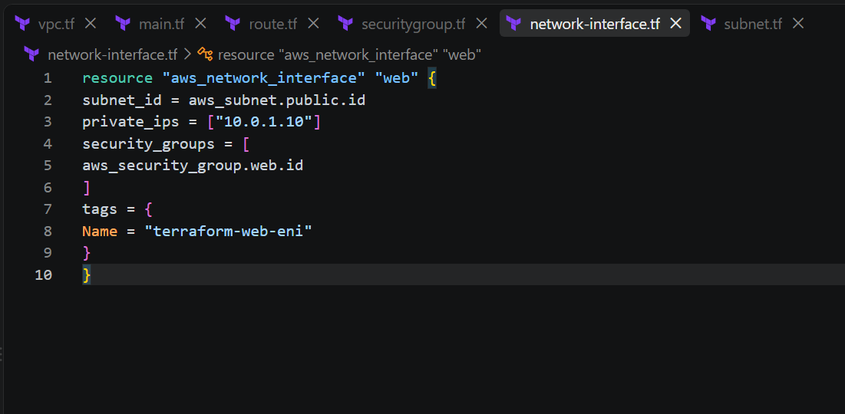
Screenshot 8 — Original task evidence
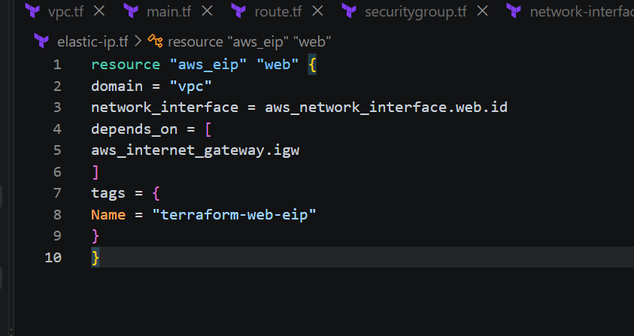
Screenshot 9 — Original task evidence

Step 5 — Create VPC
Create an isolated AWS VPC using the CIDR block 10.0.0.0/16.
resource "aws_vpc" "main" {
cidr_block = var.vpc_cidr
tags = {
Name = "terraform-final-vpc"
}
}
Screenshot 2 — Original task evidence

Step 6 — Create Internet Gateway
Create an Internet Gateway and attach it to the VPC so the VPC can communicate with the internet.
resource "aws_internet_gateway" "main" {
vpc_id = aws_vpc.main.id
tags = {
Name = "terraform-final-igw"
}
}
Screenshot 2 — Original task evidence
Screenshot 3 — Original task evidence

Step 7 — Create Subnet
Create a subnet inside the VPC for the Ubuntu EC2 server.
resource "aws_subnet" "public" {
vpc_id = aws_vpc.main.id
cidr_block = var.subnet_cidr
availability_zone = var.availability_zone
map_public_ip_on_launch = false
tags = {
Name = "terraform-final-public-subnet"
}
}
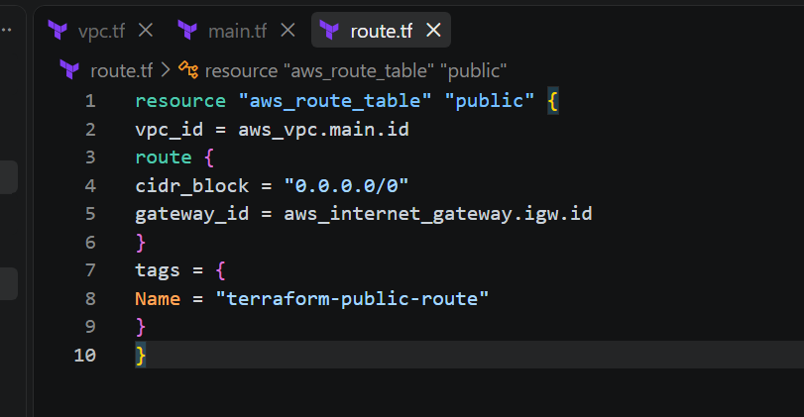
Screenshot 4 — Original task evidence

Step 8 — Create Route Table and Associate the Subnet
Create a custom route table with a default route to the Internet Gateway, then associate the subnet with the route table.
resource "aws_route_table" "public" {
vpc_id = aws_vpc.main.id
route {
cidr_block = "0.0.0.0/0"
gateway_id = aws_internet_gateway.main.id
}
tags = {
Name = "terraform-final-public-rt"
}
}
resource "aws_route_table_association" "public" {
subnet_id = aws_subnet.public.id
route_table_id = aws_route_table.public.id
}
Screenshot 3 — Original task evidence
Screenshot 4 — Original task evidence

Step 9 — Create Security Group
Allow SSH on port 22, HTTP on port 80, and HTTPS on port 443. Allow outbound traffic through the egress rule.
resource "aws_security_group" "web" {
name = "terraform-final-sg"
vpc_id = aws_vpc.main.id
ingress {
description = "SSH"
from_port = 22
to_port = 22
protocol = "tcp"
cidr_blocks = ["0.0.0.0/0"]
}
ingress {
description = "HTTP"
from_port = 80
to_port = 80
protocol = "tcp"
cidr_blocks = ["0.0.0.0/0"]
}
ingress {
description = "HTTPS"
from_port = 443
to_port = 443
protocol = "tcp"
cidr_blocks = ["0.0.0.0/0"]
}
egress {
from_port = 0
to_port = 0
protocol = "-1"
cidr_blocks = ["0.0.0.0/0"]
}
tags = {
Name = "terraform-final-sg"
}
}
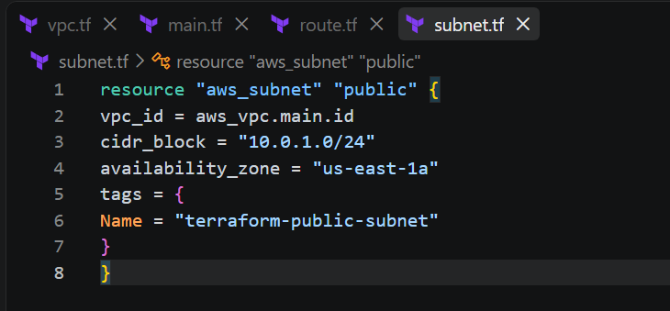
Screenshot 5 — Original task evidence
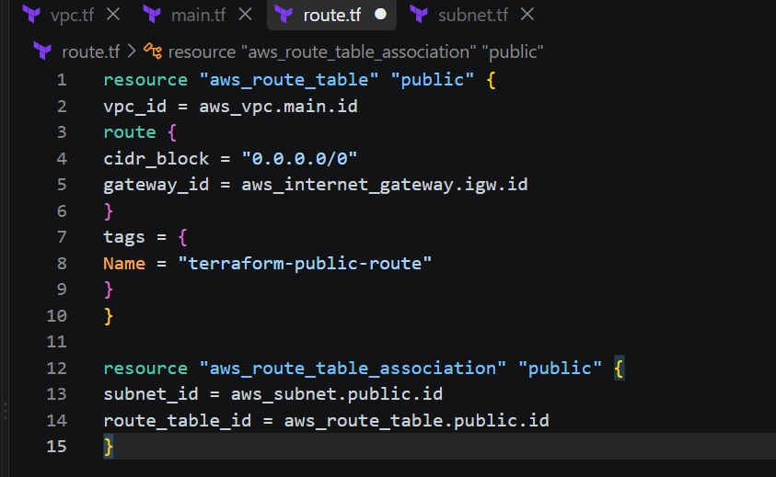
Screenshot 6 — Original task evidence

Step 10 — Create Network Interface
Create an Elastic Network Interface (ENI) with the private IP 10.0.1.10 and attach the security group.
resource "aws_network_interface" "web" {
subnet_id = aws_subnet.public.id
private_ips = [var.private_ip]
security_groups = [aws_security_group.web.id]
tags = {
Name = "terraform-final-eni"
}
}
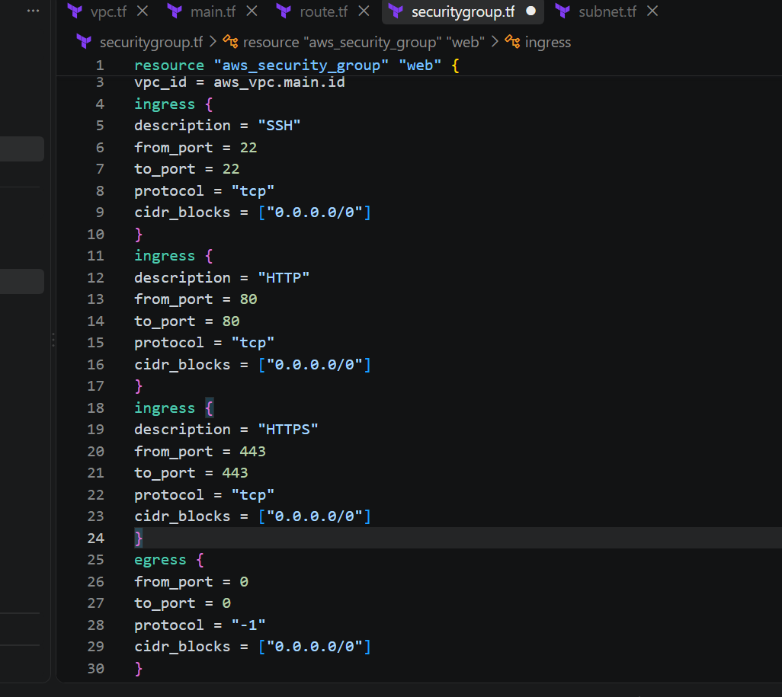
Screenshot 7 — Original task evidence

Step 11 — Assign Elastic IP
Assign an Elastic IP to the network interface to provide a public static IP address.
resource "aws_eip" "web" {
domain = "vpc"
network_interface = aws_network_interface.web.id
depends_on = [
aws_internet_gateway.main
]
tags = {
Name = "terraform-final-eip"
}
}
Screenshot 7 — Original task evidence
Screenshot 8 — Original task evidence

Step 12 — Create Ubuntu EC2 Server and Install Apache2
Create an Ubuntu EC2 instance and use user data to update the system, install Apache2, enable the service, start the service, and create the web page.
resource "aws_instance" "web" {
ami = var.ami_id
instance_type = var.instance_type
key_name = var.key_name
network_interface {
network_interface_id = aws_network_interface.web.id
device_index = 0
}
user_data = <<-EOF
#!/bin/bash
apt update -y
apt install -y apache2
systemctl enable apache2
systemctl start apache2
echo "Terraform Final Task - Apache2 Server" > /var/www/html/index.html
EOF
tags = {
Name = "terraform-final-ubuntu"
}
depends_on = [
aws_eip.web
]
}
Screenshot 9 — Original task evidence
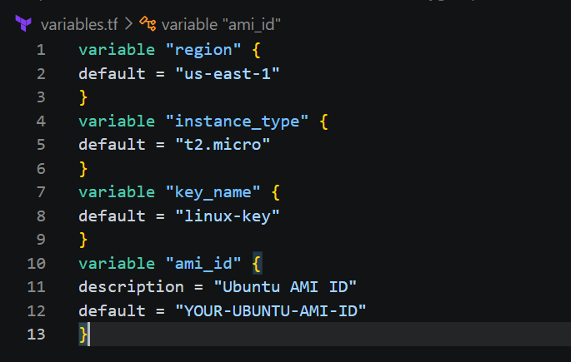
Screenshot 10 — Original task evidence

Step 13 — Initialize Terraform
Initialize the Terraform working directory and download the required provider.
terraform init
Screenshot 10 — Original task evidence

Step 14 — Format Terraform Files
Format all Terraform configuration files using the standard Terraform format.
terraform fmt
Screenshot 10 — Original task evidence
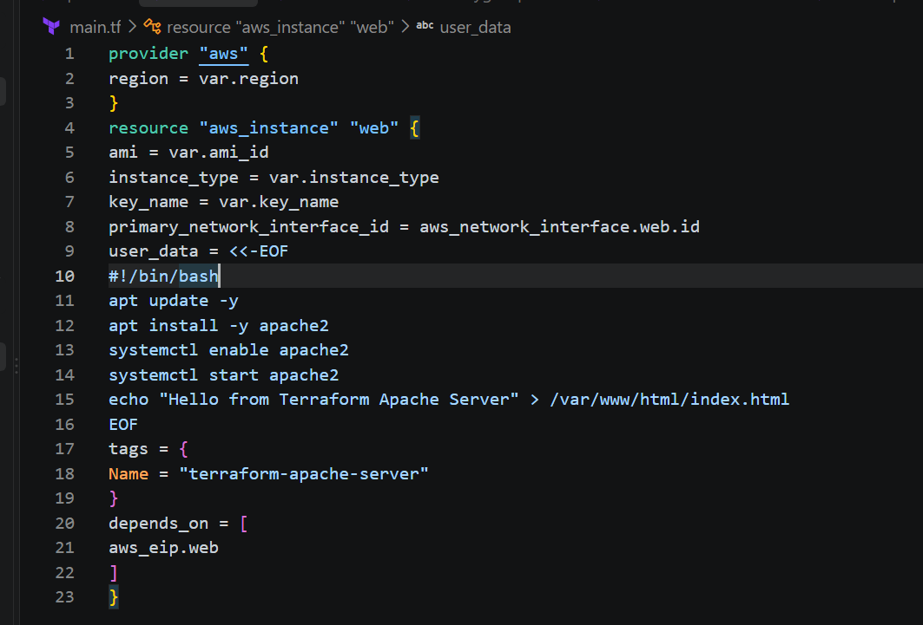
Screenshot 11 — Original task evidence

Step 15 — Validate the Configuration
Validate the Terraform configuration before creating any AWS resources.
terraform validate
Screenshot 11 — Original task evidence

Step 16 — Create Terraform Plan
Review the execution plan to confirm which resources Terraform will create, change, or destroy.
terraform plan
Screenshot 11 — Original task evidence

Step 17 — Apply the Terraform Configuration
Apply the configuration to create the AWS resources. When Terraform asks for confirmation, enter yes.
terraform apply
# When prompted:
yes
Screenshot 11 — Original task evidence
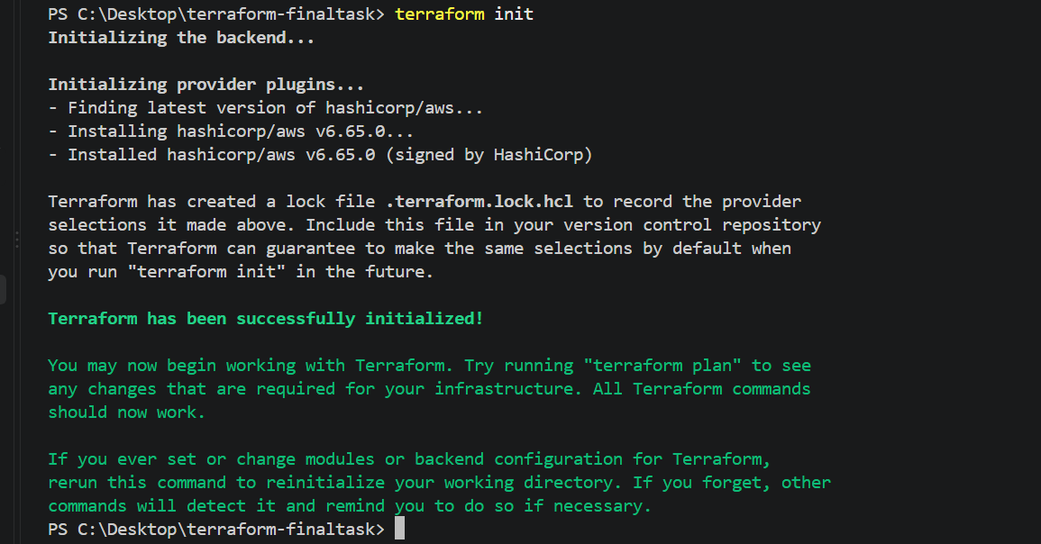
Screenshot 12 — Original task evidence

Step 18 — Verify Terraform Resources
Verify the Terraform outputs and confirm that the expected resources are present in the Terraform state.
terraform output
terraform state list

Step 19 — Connect to the Ubuntu Server
Use SSH with the configured key pair and the Elastic IP assigned to the server.
ssh -i C:\Users\<YOUR-USER>\Downloads\Krishna6.pem ubuntu@<ELASTIC-IP>
Screenshot 12 — Original task evidence

Step 20 — Verify Apache2
Check the Apache2 service status and test the web server locally from the Ubuntu instance.
systemctl status apache2
curl http://localhost
# Expected:
Terraform Final Task - Apache2 Server
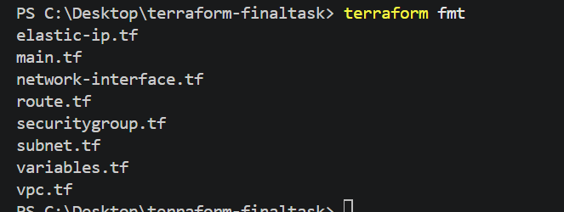
Screenshot 13 — Original task evidence

Step 21 — Verify Apache2 from the Browser
Open the Elastic IP address in a web browser. The Apache page should display the configured message.
http://<ELASTIC-IP>
Screenshot 13 — Original task evidence

Final Terraform Workflow
The complete workflow for this task is:
Write Configuration
↓
terraform init
↓
terraform fmt
↓
terraform validate
↓
terraform plan
↓
terraform apply
↓
Verify Resources and Apache2

